https://www.polly.ai/help/slack/creating-polls
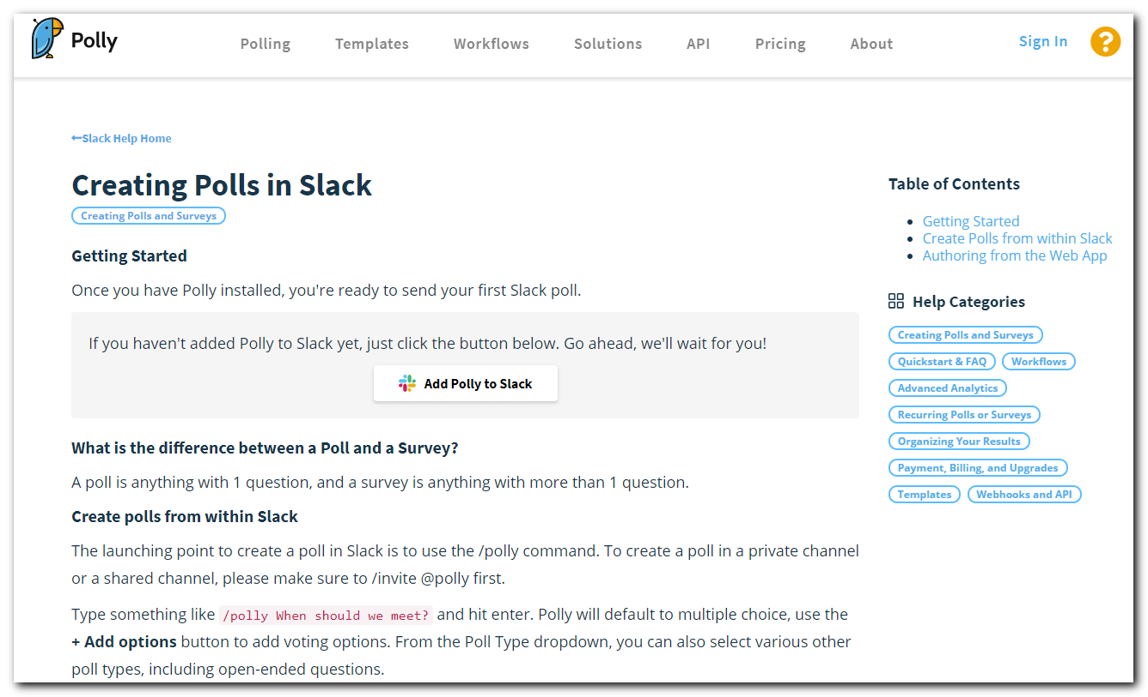
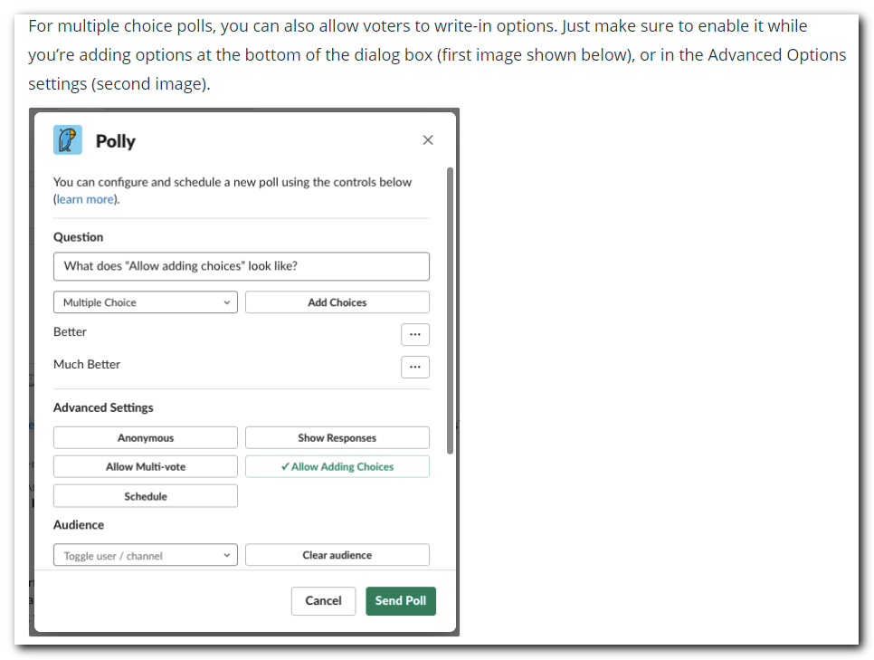
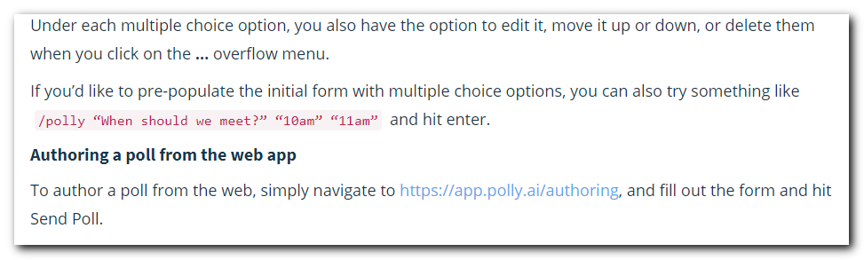

#
# 20200303
# How it was created by not me.
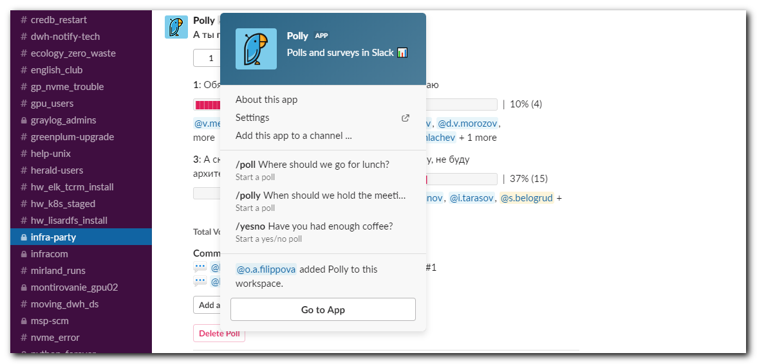

#
# And how I was created the quiz.
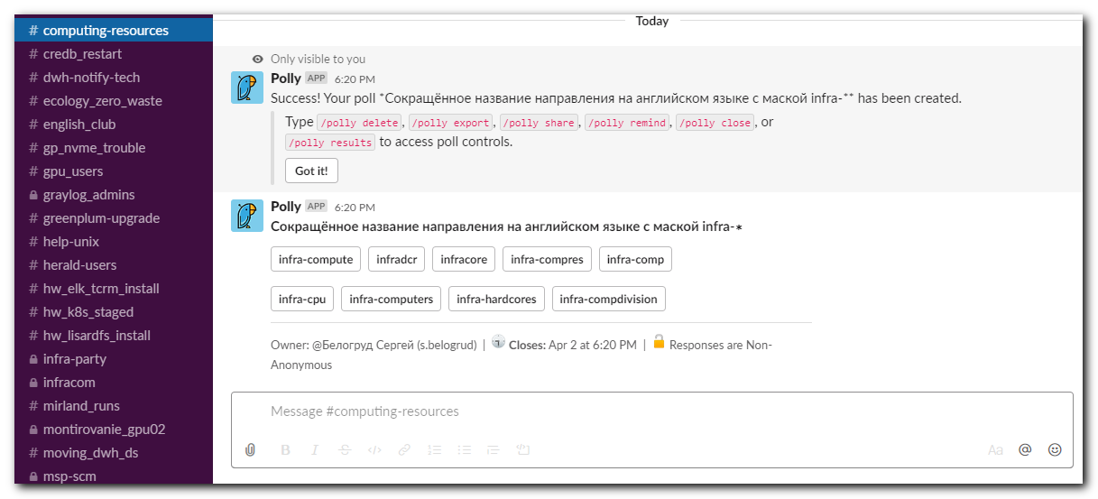

#
# One line command.
#
/polly “Сокращённое название направления на английском языке с маской infra-∗” "infra-compute" "infradcr" "infracore" "infra-compres" "infra-comp" "infra-cpu" "infra-computers" "infra-hardcores" "infra-compdivision"

